**3-D MODELLING**

3D modelling is the process of creating three-dimensional representations of an object or a surface. 3D modelling is used to shape many of the things we see in our everyday lives. 3D modelling technology has benefited our day-to-day lives in all areas from studies to video games to architecture. Computer-based 3D modelling softwares are used on a large scale to prepare 3D models.

An object’s size, shape, and texture can be determined during the 3D modelling process. The process works with points, lines, and polygons to create 3D modelling.

It is the process of developing a mathematical coordinate-based representation of any surface of an object (inanimate or living) in three dimensions. Specialised software is used for developing the representation by manipulating edges, vertices, and polygons in a simulated 3D space.

An artist uses special software to manipulate points in virtual space(called vertices) to form a collection of vertices that form an object referred to as a mesh. By changing the form of the mesh or manipulating vertices these 3D objects can be generated automatically or created manually. These points are mapped into a 3D grid and joined together as polygonal shapes, usually triangles or quads. Each point or vertex has its position on the grid. By combining these points or vertex into shapes, the surface of an object is created.

The project, design, and environmental compliance assessments can all be done with 3D models.

To make the 3D model a reality, teams use these control methods to guide equipment to create the lines, points and surfaces exactly as depicted in the model. Pre-bidding also benefits from these models, Contractors may test out different designs and convey ideas.

A process called 3D rendering is also used to display the 3D model as a two-dimensional image or used in a computer simulation of physical phenomena.

Earlier, many computer games used pre-rendered images of 3D models as sprites before computers could render them in real-time. The designer can then see the model in various directions and views, this can help the designer to see if the object is created as intended compared to their original vision. Seeing the design this way can help the designer or company figure out changes or improvements needed to be done to the model.

**Process for creating 3D models**

3D modelling is a unique combination of technical and artistic skills. It's a new arena with a lot of potential in the job market, Many people take it as a great hobby. 3D modelling has various applications that can come in handy in everyday life.

The basic idea of 3D modelling is to create three-dimensional shapes which are then visualized in different ways. The final result may be a static scene rendered from a specific angle or a detailed model that can be examined from all angles.

When you are trying to create any object, when working with 3D, you usually start with a basic geometric shape (a cube, sphere, cylinder, etc.) and tweak it with various modifiers until it resembles what you want. The main process is to modify those shapes on several levels. You can either move the whole object around, or you can break it down into its components and work with them. For instance, when you are using a cube or a cone, you may select one of its sides, or just one edge of that side or anyone vertice and modify only that one area.

Primarily the artist will build upon a basic form and manipulate it using various modelling tools. For 3D modelling, it’s almost always a good idea to start simple and improve upon it depending on the complexity you desire. A variety of tools exist to speed up the modelling process.

A widely used technique is the mirroring technique which lets the artist build a symmetrical model by only working on one-half or even one-quarter of the object. This is generally used in character design. In this process, an artist needs to model one side of the character and the software will mirror their work along the desired axis creating a perfectly symmetrical object. Other tools allow for the quick deformation of a model’s surface.

**Steps to start making 3d models for beginners**

The most important terms used in the building blocks of 3D modelling. are as under:

**· Vertex**: A single point and the smallest component of a 3D model.

**· Edge:** A straight line that connects two vertices. Edges define the shape of a 3D model.

**· Polygon**: Any shape that’s formed by connecting straight lines. There are several types of polygons (equilateral, equiangular, regular, irregular, cyclic, convex, and concave) depending on the number of sides and the extent of the angles.

**· Face**: The most basic part of a polygon mesh. It is the space between the edges.

**· Mesh**: A collection of polygons that are connected along their edges. A 3D object consists of one or more 3D meshes.

Every 3D modelling program uses a 3D environment, which is made navigable using vectors and planes.

**· Vector**: Indicates directionality and orientation, usually along the 3 axes.

**· Plane:** Two-dimensional surface oriented along one of the 3 axes.

There are three main types of 3D modelling used in CAD software: **wireframe modelling, surface modelling** and **solid modelling**.

In addition to the main three, some of the other methods of 3D modelling can be described herein below. Each artist uses the model depending on his requirement.

**· Sculpting** uses brushes and other tools to smooth, grab, push, and manipulate surfaces into more organic models.

**· Box modelling** is generally used for hard surface modelling. It usually starts with a primitive object like a cube or shape. This object is then transformed into a model. A large portion of an object or whole object is manipulated in one go.

**· NURBS** stands for non-uniform rational basis spline, a 3D modelling technique used to generate surfaces and curves. Its flexibility and precision make it easier to generate shapes.

**· NURMS** stands for non-uniform rational mesh smooth, a 3D modelling technique used to smoothen meshes.

**· Polygon modelling** makes use of faces, edges, and vertices to edit parts of a 3D model. The shape of an object is altered by changing the coordinates of one or more vertices.

Some of the basic points to be kept in mind in case of first-timers can be described as follows

· **Deformations in CAD programs** help a 3D designer modify the surface of the model. Deformation tools can be used to create a high polygon count especially when one has to experiment to design a complex model before the gets the correct design. In this process, the designer can work in a way that preserves the original model. In deformations, the topology of the model isn’t changed.

**· Manipulation** is transforming an already-designed model to suit your needs. Transformation tools in CAD programs are the most widely-used tools for manipulation.

**· Binary operations**: A polygonal modelling operation performed to create a new mesh from two other meshes. Two or more meshes can be joined together or intersected.

**· Measurements**: This is the computation of the values of the mesh. You can measure the following: volume, surface area, cross-section, and also fitting.

**Types of 3d modelling**

**Wireframe modelling**

A wireframe model is an exact representation of a real-world, three-dimensional object used in 3D computer modelling. In this type of modelling, three vertices (or triangles) make the basic element of wireframe models. The geometric face is composed of at least three vertices. The person working on it designs the shape and dimension of the object by making changes to each vertex position. One or more faces may share the same vertex. The more triangles, more the realistic the model. The “polygon count” indicates the total number of triangles contained within a wireframe model.

The use of wireframe modelling in CAD comes from two major aspects: **computer representation of an object**--- which concerns the structure of the model, **and the computational procedures** to manipulate visualization of the representation.

Wireframe structures contain only two types of information—

1. The geometric data about the coordinate positions of connecting points in the 3D model.
2. Second, the topological data that translate connected points as edges.

It is created by specifying each edge of the physical object where two mathematically continuous smooth surfaces meet. It can also be achieved by connecting an object's constituent vertices using (straight) lines or curves.

The term "wireframe" comes from designers using metal wire to represent the three-dimensional shape of solid objects. 3D wireframe computer models allow for the construction and manipulation of solids and solid surfaces.

Using a wire-frame model allows for the visualization of the underlying design structure of a 3D model. In cases where a relatively high screen frame rate is needed, wireframe renderings are used are they are relatively simple and fast to calculate. Wireframe modelling is so versatile that you can build almost anything with this type of modelling. It allows you to experiment with any shape, colour and style.

**An image of 3D Wireframe Modeling**

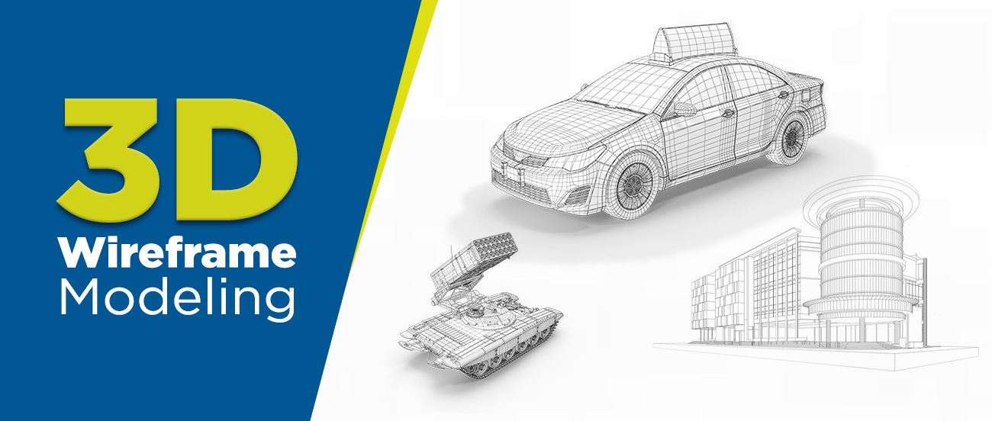

SEVERAL MODELS CAN BE PREPARED IN THE ABOVE FASHION WITH THE HELP OF THIS TYPE OF MODELING

**Advantages of wireframe modelling**

**· Provides a complete 3D view--** This technique is important in 3D modelling as it offers a complete 3D view of the model from all perspectives and angles. Using this, the designers not only get an idea of the future product but also understand its exact dimensions and specifications.

**· Close examination of the object composition--**The process helps creators get a complete 3D view of the object. It also helps in building a complete design strategy as it provides a close examination of the object’s wireframe and its composition, like distance, potential difference, etc.

**· Automates orthographic and auxiliary views--**By creating wireframes in 3D, creators get various kinds of views, like orthographic and auxiliary views. Designers can gain a thorough understanding of the model by using these views, as both provide detailed information on how the design and the future object will be.

**· Suitable for higher frame rate--**Wherever a higher frame rate is required, creators can opt for this wireframe modelling method as it helps keep the designs and process streamlined and structurally perfect.

**· Simple to construct--**3D modelling can be a complex process for some, but the wireframe modelling process makes it easy for all. It accomplishes this by simplifying complex designs and assisting designers in creating designs effortlessly.

**Disadvantages**

**· Designs create confusion**—more so for beginners as it is a composition of various designs, dimensions, arcs, and other important details. This may cause the process to appear confusing at first, but it gets easier for professionals.

**· Not apt for mass calculations and voluminous designs or complex solid designs**--This technique has its limitations when it comes to mass calculations or when you have to create designs in large volumes or designs which are complex in nature

· **Creates ambiguous views**--Ambiguity comes naturally with this modelling process. This is why the models developed through this always remain vague and are not ideally considered to be exact representations of the objects.

In short 3D wireframe type of modelling has its advantages, the user has to first envisage what he desires to achieve, the time frame and resources available to him and the confidence he has in himself to present the final picture before the audience so that his achievement receives accolades and can be put in operation in the best possible way.

**Surface modelling**

The primary purpose of a surface model is to showcase an object in 3D the way it is supposed to be visible in the real world. High computational power is required to run the right software for seamless integration among edges

Surface modelling relies on an object’s positioning and curvature. It also matters how you can validate imperfections and apply smoothness across the image. A smooth transition from one vertex to the next is required.

A significant problem with this method is that the visual representation of surfaces may contain geometry that cannot exist in the real world, also known as non-manifold geometry.

Surface modelling focuses heavily on the visual representation of an object’s exterior. The object can be anything from organic shapes like fruits or animals, electronic devices like radios or phones, to complex structures like bridges and skyscrapers.

Surface models require clearly defined curves, contours, and textures of the outer shell. An object can still be geometrically incorrect – without definite volume or thickness – in a surface model as long as you don’t plan to manufacture the model. This flexibility gives designers the unlimited possibility to shape a model in a way that the solid modelling method cannot. On the other hand, you cannot slice open a surface model since the interior is empty; it is a hollow object.

The following picture is one such example of Surface Modeling. A detailed study of it will reveal the advantages as well as the limitations it poses when used.

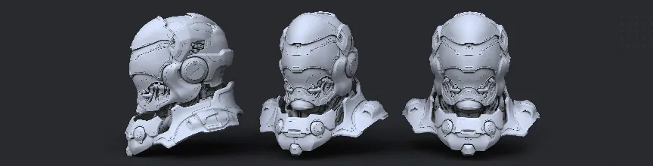

**Advantages of Surface modelling**

When working with certain design software applications it is not always possible to create or add features to a model, mainly because of software limitations. In such cases, surface modelling is important to depict specific features.

Highly precise complex shapes which require working with one face at a time can be accomplished only with Surface modelling skills.

When designers are required to switch between solid and surface modelling works surface modelling is needed. Advanced modelling techniques like hybrid modelling require Surface modelling.

Surface modelling helps a person to continue working with a continuous flow or to make changes to Dumb solids. These often feature missing data or details when imported into another CAD tool.

With the help of modern software, readily available in the market, Surfacing has become much easier than it was earlier. It requires less effort and training in the field as compared to other methods

**Disadvantages of Surface Modeling**

1. Difficult to construct.- It takes a lot of time and effort to construct the required models and becomes more tedious when the final product is not approved in toto and requires changes to be made.

2. Difficult to calculate mass property—Due to the very nature of the model calculating the mass property poses a great problem.

3. More time is required for creation- due to the complexity and detail involved in its creation,

4. Requires high storage space as compared to wireframe modelling.

5. Also requires more time for manipulation.

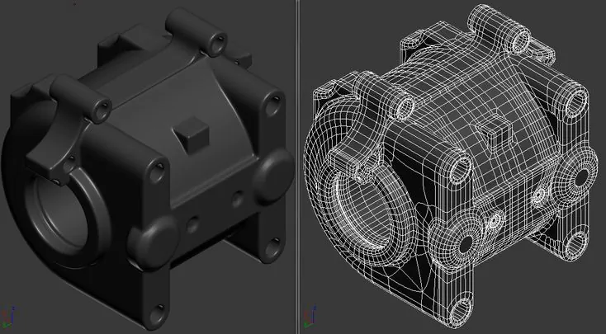

**Solid modelling**

It is a type of modelling where a particular shape or form is made by the use of CAD software. This technique can be used for almost any product design, whether it is a car or a house.

Solid models must allow for visualization and animation of the inner workings or moving parts of an object. Otherwise, they are concealed under the surface and hidden from plain sight during real-world application.

CAD programs use different procedures to build a solid model. Some add solid objects over another combination and placement to produce complex figures. Others extrude shapes from two-dimensional sketches to construct 3D assets.

Solid models almost always come from primitive shapes such as cubes, cylinders, prisms, spheres, and cones.

The process can also start with multiple three-dimensional figures, allowing you to create pretty much every imaginable object. That includes not only machines and mechanical elements but also fantastical items and representations of natural things.

There are four key elements of a solid model:

**· Complete**: various points within the modelling environment classified as inside or outside. The purpose is to provide accurate division between the object’s surface and all else beneath it.

**· Valid**: edges, faces, and vertices must be connected in the proper configuration to deliver a clear view of the 3D object.

**· Unambiguous: design clarity and certainty**. There can only be one single interpretation of all the design aspects drawn. A solid model must be realistic in the sense that the digital object represents its true shape in reality.

· Solid: the object needs to have true-to-life topological and geometric data including shape, size, weight, and connectivity of edges.

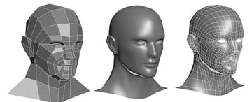

**Advantages**

Solid modelling is one of the most important applications of CAD software and it has been becoming increasingly popular of late. Solid modelling CAD software helps the designer to see the designed object as if it were a real manufactured product. It can be seen from various directions and in various views. This helps the designer to be sure that the object looks exactly as it wanted it to be. It also gives additional vision to the designer as to what more changes can be done to the object.

Solid modelling is used not only for creating solid models of machine parts, but also the buildings, electric circuits and even human beings. Solid modelling software is being used for a large variety of applications, here are some of them:

**1) Engineering**: The engineering design professionals use solid modelling to see how the designed product will look like. The architects and civil engineers use it to use the layout of the designed building.

**2) Entertainment industry**: The animation industry has been using solid modelling to create various characters and movies.

**3) Medical industry**: Modern imaging scanners are being used to create solid models of the internal parts of the body. This helps the doctors to visualize specific tissues of the body, design various medical devices etc.

**Disadvantages**

Though disadvantages can be laid down only as and when one lays his hands on this type of modelling, some of the basic limitations can be put forth:-

**.** Solid modelling can be disadvantageous as it becomes too slow for highly conceptual designs--- In the early stages, we think faster than making the same model in 3D, by making preliminary sketches on paper. So it appears to be much slower

.Requires a lot of computer power—To prepare a basic model and redesign it till perfection is achieved can prove to be time-consuming many times in turn involving many computer hours and in turn power.

.Cheaper these days, but not a negligible expense.

.Some design changes can be slower and harder. -File interchange between 3-D parametric CAD systems is even worse than among 2-D systems. PTC, Solidworks, Autodesk, and the like need to play better with each other if any of them want to take credit for supporting collaborative work.

**Surface modelling VS Solid modelling**

Solid modelling is for representing solid objects in the areas of CAD, engineering analysis, graphics and animation as well as prototyping and product visualization. It uses mathematical principles to create 3D solid objects.

The object can be seen in geographic terms and is considered a “watertight” model because the internal details of the product are often included. Each part of the model is added one at a time until the complete model is finished. Assembly modelling can also play a part in solid modelling, which is simply when smaller parts of the model make up the whole.

Solid models can intersect, join and subtract objects from one another to create the desired results as far as shape and form.

Surface modelling focuses more on the external aspects of an object. It develops an object by stretching a surface over it with 3D curves created by the designer. It is essentially describing the surface boundaries of the object. It allows the viewer to see each surface point where the solid interior is located.

This type of modelling is used for creating the external aesthetics of a product or design. It can allow for more free-form shapes and it is considered sleeker by some. It lacks the “watertight” feature of solid modelling because if you were to cut into the design, it would be hollow. This gives solid modelling an advantage over surface modelling because the object can be defined more intricately, giving you a better idea of how the product or design will perform.

Another difference between solid and surface modelling is what they can do while you are developing a design. When developing designs using surface modelling, it can be hard to go back and make changes because they are not parametric. Making changes in one area may not create updates in the whole design. Solid models, on the other hand, are parametric, so you can look at the commands you used to create the design.

Each type of modelling serves its purpose depending on the type of design you are working on, so the pros and cons of each should be weighed to see which one will work for the design concept you have so that you can make the best use of their benefits.

Conclusion: In the end, the basic fact remains, that deciding the type of 3D modelling to be used should be determined by penning down, your final object, the time available, the resources available and last but not the least the finance approved for the product.

**References :**

* [**https://www.futurelearn.com/info/blog/general/what-is-3d-modelling#What_is_3D_modelling_used_for**](https://www.futurelearn.com/info/blog/general/what-is-3d-modelling#What_is_3D_modelling_used_for)
* [**https://en.wikipedia.org/wiki/3D_modeling**](https://en.wikipedia.org/wiki/3D_modeling)
* [**https://www.makeuseof.com/how-to-start-3d-modeling-a-beginners-guide/**](https://www.makeuseof.com/how-to-start-3d-modeling-a-beginners-guide/)
* [**https://conceptartempire.com/what-is-3d-modeling/**](https://conceptartempire.com/what-is-3d-modeling/)
* [**https://www.aeliusventure.com/3d-modeling-explained-what-is-3d-modelling-and-why-is-it-useful/**](https://www.aeliusventure.com/3d-modeling-explained-what-is-3d-modelling-and-why-is-it-useful/)
* [**https://www.answers.com/Q/Advantages_and_disadvantages_of_solid_modeling_using_cad**](https://www.answers.com/Q/Advantages_and_disadvantages_of_solid_modeling_using_cad)
* [**https://www.indovance.com/knowledge-center/solid-modeling-versus-surface-modeling/**](https://www.indovance.com/knowledge-center/solid-modeling-versus-surface-modeling/)
* [**https://www.queppelin.com/types-of-3d-modeling-with-pros-and-cons/**](https://www.queppelin.com/types-of-3d-modeling-with-pros-and-cons/)
* [**https://www.cadcrowd.com/blog/do-you-know-the-three-major-types-of-3d-models/**](https://www.cadcrowd.com/blog/do-you-know-the-three-major-types-of-3d-models/)
* [**https://all3dp.com/2/3d-modeling-basics-simply-explained/**](https://all3dp.com/2/3d-modeling-basics-simply-explained/)